Question 1
A hospital management system involves scheduling incoming patients’
appointments with doctors based on the reason of admission to the hospital.
Patients appointments are made on a first come first served basis. A doctor
has a weekly hourly schedule where s/he is either: available for an
appointment, on appointment, or outside office. If the patient already
visited the hospital for the same doctor specialty, it is desirable that the
patient be scheduled to the same doctor s/he previously visited.
- Doctor schedule can be represented using a 2-D array of dimension
7(days)*24(hours). The values inside the array (0, 1, or 2) can
represent the 3 availabilities status of the doctor.
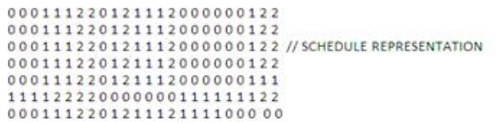
- Patients are scheduled an appointment with a doctor based the order
of their arrivals, so a queue data structure of patients can be used.
- Patients record need to be stored for fast lookup. Therefore, a BST
might be used to store the patient record with the SSN as the unique
search key.
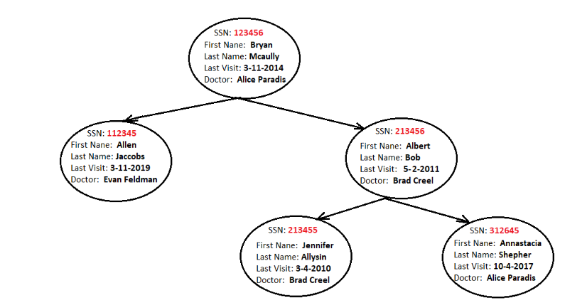
Example of Hospital Management Menu:
1. Lookup Patient Information
2. Add a patient to the queue
3. Schedule Appointment for enqueued patients
4. Add New doctor
5. Lookup doctor Schedule

Example of Additional Functionalities:
1. Group doctors by departments and schedule patients to doctors from
the right department based on their symptoms (a symptom-specialty
hash map can be used).
2. Add dedicated nurses to each doctor and schedule an available
appointment for the doctor and a nurse.
3. Make a priority queue of patients based on the urgency of the
patient case.

Question 2
Object Oriented Airlines (OOA) has finally decided to automate its flight scheduling. They want a new program and they are hiring you to write it for them. You'll have the rights to your new software and since you can sell it to other airlines, you need to make your program flexible.
OOA, or another airline, will provide you with a list of flights.
Each flight has the following properties:
- A flight number (integer 0 - 999)
- A departure airport
- A departure date
- An arrival airport
- A seating list
Each seating list has the following properties:
- The number and range of first class seats
(i.e. 5 seats, seats 1, 2, 3, 4, and 5).
- The number and range of business class seats
(i.e. 10 seats, seats 6 - 15)
- The number and range of economy class seats
(i.e. 20 seats, seats 16 - 35)
Note: A particular class can have an arbitrary range of seats
(i.e. first class, 5 seats, seats 1, 5, 9, 11, 21).
Once the list of flights is given, you are ready to start scheduling passengers.
The scheduling must handle several operations.
S
chedule a passenger for a flight
Choose a flight number. Choose a class. If all the seats are full, give the option to put the passenger on a wait list. There should be a wait list for every class (first, business, and economy).
C
ancel a passenger from a flight
Choose a passenger. Choose a flight. If there are passengers on the wait list, print the name of the next passenger and give the option to schedule that passenger for the available seat.
P
assenger status: print the status of a passenger
Choose a passenger. If the passenger is scheduled for a flight, print the flight information. If the passenger is on a wait list, print the flight information and the passenger's position on the wait list.
F
light information: print the information for a flight
Print the departure airport, the departure date, the arrival airport, and a list of all the seats and the name of the passenger in each seat.

Design and Implementation
There are many ways this program could be implemented, many different data structures and algorithms that could be used, and many ways the project description could be extended and made more realistic. It will be interesting to think about these issues during the project and as we explore more sophisticated data structures. For now, however, try to keep it as simple as possible. Use the sequential container classes (lists, vectors, deques, stacks and queues) from the standard (STL) library where needed, and use the STL algorithms whenever you can.
Pay particular attention to the design of your classes. Here is an outline of classes you might have:
- A class that represents the seating list. Each seat should have a number, a class, and field for the passenger name.
- A class that represents a flight. It should have the appropriate data structures for storing the departure and arrival information and it should include a seating list.
- A class that represents a passenger. A passenger may be scheduled for several different flights or may be waiting on several different wait lists. The appropriate data structures should be in place for maintaining the different information associated with each passenger.
The member functions defined for each of these class objects should support the above outlined scheduling operations. They should do so in such a way that the implementation details (the lists, queues, etc.) are hidden from the outside world. Start your programming task by determining which classes do what operations and then decide on the implementations within each class (some will be simple, others not).

